ONLINE ATTENDANCE MANAGEMENT SYSTEM
FOR ORGANIZATION

A PROJECT REPORT
SUBMITTED BY

ALLURI SURAJ REDDY (17K81A05C5)

AT
ECIL-ECIT
(ELECTRONIC CORPORATION OF INDIA LIMITED)
UNDER THE ESTIMATED GUIDANCE OF

Mr. SRIDHARA SHETTY (AGM, CED)

BACHELOR OF TECHNOLOGY
IN
COMPUTER SCIENCE ENGINEERING

ST.MARTIN’S ENGINEERING COLLEGE
Dhulapally, Near Kompally,Secunderabad-500 100.
(AFFILIATED TO JNTUH)

ACKNOWLEDGMENT
We wish to take this opportunity to express our deep gratitude to all the people who have extended their cooperation in various ways during our project work. It’s our pleasure to acknowledge the help of all those individuals.

We would like to thank Mr. SRIDHARA SHETTY and our project guide Mr. V.Y.BHARADWAJ, M. Tech for guidance and help throughout development of this project work by providing us with required information. Without her guidance, cooperation and encouragement, we couldn’t learn many new things during our project tenure.

We would like to thank Mr. P.UDAYA KUMAR (HOD, CSE DEPT) for his encouragement and valuable guidance in bringing shape to dissertation.

ALLURI SURAJ REDDY 17K81A05C5

DECLARATION
We hereby declare that the project entitled “ONLINE ATTENDANCE MANAGEMENT SYSTEM FOR ORGANIZATION” Submitted for the B. Tech in COMPUTER SCIENCE ENGINEERING. This dissertation is our original work and the project has not formed the basis for the award of any degree, associate ship, fellowship or any other similar titles and no part of it has been published or sent for the publication at the time of submission.

Alluri Suraj Reddy (17K81A05C5)

Contents:-
1 INTRODUCTION
1.1 ABSTRACT
2 ORGANIZATION PROFILE
3 SYSTEM ANALYSIS
3.1 EXISTING SYSTEM
3.2 PROPOSED SYSTEM:
4 PROJECT OVERVIEW
4.1 ADMIN
4.2 STUDENT
4.3 FACULTY
5 DEFINITIONS, ACRONYMS, ABBREVIATION
6 SYSTEM REQUIREMENTS
6.1 software Requirements:
6.2 hardware Requirements:
7 TECHNOLOGIES
8 SYSTEM DESIGN
9 SCREEN
10 DATABASE DESIGN
11 TEST PROFILE, TEST PLAN
12 CONCLUSION
13 BIBLIOGRAPHY

1. INTRODUCTION
1.1 ABSTRACT
TITLE OF PROJECT: ONLINE ATTENDANCE MANAGEMENT SYSTEM FOR ORGANIZATION
Introduction:
ONLINE ATTENDANCE MANAGEMENT SYSTEM FOR ORGANIZATION is developed for any organization which needs to maintain the attendance system. The proposed model has a greater security in the sense that each user high security password is confirmed before he/she open there respective pages in the main database of the organization. The additional feature of the model is that the user can modify there details. In this model only a the admin has the assess to modify any details of the user . The user can view the attendance and if he/she has any issue in the data the can reach up to the admin and can correct it.
MODULES DESCRIPTION
The system after careful analysis has been identified to be presented with the following:
The Modules involved are
1. Admin
2. Student
3. Faculty
Admin Module:
Admin can login to the system by default user name and password then he can change the login credentials. Admin can accept or reject the users. Admin can view the list of student and faculty. Admin have to accept the new registration so that students and faculty can use this system. Admin has to maintain previous records and generate reports based on previous records.

Student Module:
Student have to registration them self with name, roll number, password, phone number, address, email id. Students can view their attendance. Students can only login after admin acceptance them.

Faculty Module:
Faculty have to registration them self with name, faculty id, password, phone number, address, email id. Once admin accepts the registration faculty can login into system and they can view list of Students. They can mark the attendance. Faculty can change the passwords any update the profile. They can view student attendance.

2 ORGANIZATION PROFILE

NAME OF THE ORGANIZATION: ELECTRONICS CORPORATION OF INDIA LIMITED
Website: http://www.ecil.co.in/ecil/

HISTORY:
ECIL was setup under the department of Atomic Energy in the year 1967 with a view to generate a strong indigenous capability in the field of professional grade electronic. The initial accent was on self-reliance and ECIL was engaged in the Design Development Manufacture of several products emphasis on three technology lines viz. Computers, control systems and communications. ECIL thus evolved as a multi-product company serving multiple sectors of Indian economy with emphasis on import of country substitution and development of products and services that are of economic and strategic significance to the country.
Electronic Corporation of India Limited (ECIL) entered into collaboration with OSI systems Inc. (www.osi-systems.com) and setup a joint venture “ECIL_RAPSICAN LIMITED”. This joint Venture manufacture the equipment’s manufactured by RAPSICAN, U.K, U.S.A with the same state of art Technology, Requisite Technology is supplied by RAPSICAN and the final product is manufactured at ECIL facility.
Recognizing the need for generating the quality IT professional and to meet the growing demand of IT industry, a separate division namely CED has been established to impart quality and professional IT training under the brand name of ECIT. ECIT, the prestigious offshoot of ECIL is an emerging winner and is the fore front of IT education in the country.

VISION:
To develop country in achieving self-reliance in strategic electronics.

MISSION:
ECIL’s mission is to consolidate its status as a valued national asset in the area of strategic electronics with specific focus on Atomic Energy, Defense, Security and such critical sectors of strategic national importance.

OBJECTIVES:
To continue services to the country’s needs for the peaceful uses Atomic Energy. Special and Strategic requirements of Defense and Space, Electronics Security and Support for Civil aviation sector.
To establish newer Technology products such as Container Scanning Systems and Explosive Detectors.
To re-engineer the company to become nationality and inter nationality competitive by paying particular attention to delivery, cost and quality on all its activities.
To explore new avenues of business and work for growth in strategic sectors in addition to working realizing technological solutions for the benefits of society in areas like Agriculture, Education, Health, Power, Transportation, Food, Disaster Management etc.

DIVISIONS:
The company is organized into divisions serving various sectors, national and commercial importance. They are Divisions serving nuclear sector like Control And Automation(CAD), Instruments and Systems Divisions(ISD), Divisions Serving defense sector like Communications Division(CND), Antenna Products Division(APD), Servo Systems Division(SSD) etc., Divisions handling Commercial Products are Telecom Division(TCD), Customer Support Division(CSD), Computer Education Division(CED).

EXPORTS:
ECIL is currently operating in major business EXPORT segments like instruments and systems design, Industrial/Nuclear, Server Systems, Antenna Products, Communication, Control and Automation and several other components.

SERVICES:
The company played a very significant role in the training and growth of high caliber technical and managerial manpower especially in the fields of Computers and Information technology. Though the initial thrust was in meeting the Controls and Instrumentation requirements of the Nuclear Power Program, the expanded scope of self-reliance pursued by ECIL enabled the company to develop various products to cater to the needs of Defense, Civil Aviation, Information and Broadcasting, Telecommunications, etc.

3 SYSTEM ANALYSIS

3.1 EXISTING SYSTEM:
EARLIER the main purpose of attendance is to count no of people attending school or college these count will be marked in register and can be viewed at particular hours.
3.2 PROPOSED SYSTEM:
Online attendance system is aimed at developing a web-based system. This system is completely automated. In this system the person can register online and do many things. The details of all the things are made available to them through the single website.
ADVANTAGES
1. Student can check their attendance anytime & anywhere.
2. Everyone will have individual Roll number & password
3. Faculty database permits only faculty to mark the attendance
4. No more maintains of a separate register
5. Quick results are possible..

4. PROJECT OVERVIEW
PROJECT MODULES:
Online Attendance is developed for colleges and schools for an easy and efficient work. The proposed model has a greater security in the sense that it provides an option for the student to change his/her details which even includes password. The additional feature of the model is that the faculty can set and reset the attendance details of a student. In this proposed system the updation of attendance details of every student is done every hour manually, this saves a lot of time and also maintains the efficiency
The modules involved are
1) Admin module
2) Student module
3) Faculty module
4.1 Admin Module:-
Through admin module one is capable of accessing and going through any data at any point of time
4.2 Student Module:-
In this module, a student can login and go through his/her details and also can change them if necessary at any point of time
4.3 Faculty Module:-
In faculty module , a faculty can login and go through his/her details at any point of time and also can change their details if necessary and enter the attendance details of every student and the end of every period

5 DEFINITIONS, ACRONYMS, ABBREVIATION

HTTP:
Hyper Text Transfer Protocol is a transaction oriented client server protocol between
the browser and a web server.

HTML:
Hyper Text Markup Language is a programming platform- part of the Java platform- for developing and running distributed multi-tier architecture Java applications, based largely on modular software components running on an application server.

JDBC:
Java Data Base Connectivity which is used to connect the databases with the java.

DBMS:
Data Base Management System which is used to store information. We can retrieve
information from the records in the form of the queries.

JSP:
Java Server Pages is a Java technology that helps software developers serve dynamically generated web pages based on HTML.

6. SYSTEM REQUIREMENTS

SOFTWARE REQUIREMENTS:
Operating System : Windows 7/10
Technology : Java/J2EE (Servlets, JSP, JDBC)
Web Technologies : HTML, JavaScript, CSS
Web Server : Tomcat 7.0
Database : MySQL
Software’s : JDK 1.7

HARDWARE REQUIREMENTS:
Processor : Pentium based systems with a minimum of P4
RAM : 1 GB (Minimum)

7. TECHNOLOGIES

TECHNOLOGIES
Front End or User Interface Design:
The entire user interface is planned to be developed in browser specific environment with touch of intranet-based architecture for achieving the distributed concept.
The browser specific components are designed using the html standards and dynamism of the designed by concentrating on the constructs of the java server pages.

Communication or Database Connectivity Tier:
The communications architecture is designed by concentrating on the standards of
servlets, and enterprise Java Beans. The database connectivity is established using Java database connectivity.
The standards of three tier architecture are given major concentrations to keep the standards of higher cohesion and limited coupling for effectiveness of the operations.

Languages Used:
In our project, we have chosen Java language for developing the code.
Java:
Java is a programming language originally developed by James Gosling at Sun Micro
Systems and released in 1995 as a core component of Sun Micro Systems as a java platform.
The language derives much of its syntax from C and C++ but has a simpler object model and fewer low level facilities. Java applications are typically complied to byte code that can run on any java virtual machine regardless of computer architecture.
The original and reference implementation java compilers, virtual machines and class
libraries were developed by Sun from 1995. As of may 2007, in complains with the
specification of the java communication process, Sun re license most of its java technologies under the GNU General Public License.
Principles:
There were five primary goals in creations of the java language. It should be simple,
object-oriented, and familiar.
1. It should be robust and secure
2. It should be architecture neutral and portable
3. It should execute with high performance
4. It should be interpreted and dynamic
Syntax:
The syntax of java is largely derived from C++. Unlike C++ which combines from
structure, generic and object-oriented programming. Java was built almost exclusively as an object-oriented language. All code is written in a class and everything is object with the exception of intrinsic data type, which is a not cause for performance reasons.
Java suppresses several features for classes in order to simplify the language and to
prevent possible errors anti pattern design.
JSP (JAVA SERVER PAGES)
Java Server Pages (JSP) is a Java technology that allows software developers to dynamically generate HTML, XML or other types of documents in response to a Web client request. The technology allows Java code and certain pre-defined actions to be embedded into static content.

The JSP syntax adds additional XML-like tags, called JSP actions, to be used to invoke built-in functionality. Additionally, the technology allows for the creation of JSP tag libraries that act as extensions to the standard HTML or XML tags. Tag libraries provide a platform independent way of extending the capabilities of a Web server.
JSPs are compiled into Java Servlets by a JSP compiler. A JSP compiler may generate a Servlets in Java code that is then compiled by the Java compiler, or it may generate byte code for the Servlets directly. JSPs can also be interpreted on-the-fly reducing the time taken to reload changes.
Java Server Pages (JSP) technology provides a simplified, fast way to create dynamic web content. JSP technology enables rapid development of web-based applications that are server- and platform independent.

JDBC
JDBC (Java Database Connectivity) is an API developed by Sun Microsystems that provides a standard way to access data using the Java programming language. Using JDBC, an application can access a variety of databases and run on any platform with a Java Virtual Machine.
It is necessary to write separate applications to access different database systems (Oracle and Sybase, for example). Using JDBC allows you to write one application that can send SQL statements to different database systems. SQL is the standard language for accessing relational databases.
The JDBC API defines a set of Java interfaces that encapsulate major database functionality,
such as running queries, processing results, and determining configuration information.
Because JDBC applications are written in Java, applications work on any platform.
The JDBC API makes it possible to do three things:
Establish a connection with a database or access any tabular data source
Send SQL statements-
Process the results

JDBC DRIVERS:
Today, there are four types of JDBC drivers in use:
Type 1: JDBC-ODBC bridge
Type 2: partial Java driver
Type 3: pure Java driver for database middle ware
Type 4: pure Java driver for direct-to-database
In this project we are using Type 1 driver which provides best database connectivity
for internet based application.

Type 1 JDBC Driver
JDBC-ODBC Bridge driver
The Type 1 driver translates all JDBC calls into ODBC calls and sends them to the ODBC driver. ODBC is a generic API. The JDBC- ODBC Bridge driver is recommended only for experimental use or when no other alternative is available.
Advantage:
The JDBC-ODBC Bridge allows access to almost any database, since the database ODBC drivers are already available.
Disadvantages:
1. Since the Bridge driver is not written fully in Java, Type 1 drivers are not portable.
2. A performance issue is seen as a JDBC call goes through the bridge to the ODBC driver,then to the database, and this applies even in the reverse process. They are the slowest of all driver types.
3. The client system requires the ODBC Installation to use the driver.
4. Not good for the Web.

MySQL

The database which we are using is the MYSQL database. It’s an open source and easily manageable, and is very much compatible with Java.
in LAMP- the software platform comprised of Linux, Apache, MySQL and PHP/Perl often viewed as the foundation of the Internet.
Sun is committed to enhancing and optimizing the LAMP stack on GNU/Linux and Microsoft Windows along with Open Solaris and MAC OS X. The database from MySQL, Open Solaris and Glass-fish, together with Sun Java platform and Net Beans communities, will create a powerful Web application platform across a wide range of customers shifting their applications to the Web.
More than 100 million copies of MySQL high-performance open source database software have been downloaded and distributed and an additional 50,000 copies are downloaded daily.
This broad penetration coupled with MySQL strength in Web 2.0, Software as a Service,enterprise, telecom and the OEM embedded market make it an important fit for Sun. With MySQL, Sun will have the ability to deepen its existing customer relationships and create new opportunities with companies seeking the flexibility and ease-of-use of open source systems.

8. SYSTEM DESIGN
UML DIAGRAMS
CLASS DIAGRAM

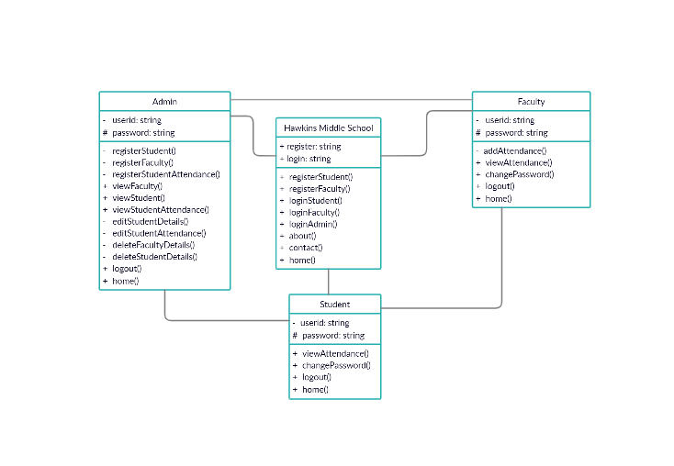

SEQUENCE DIAGRAM :
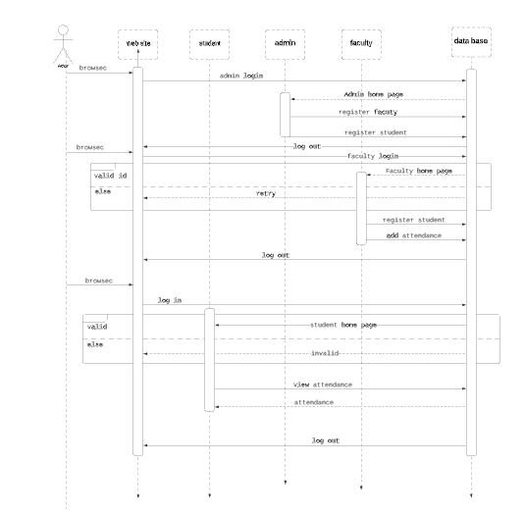

USECASE FOR STUDENT :

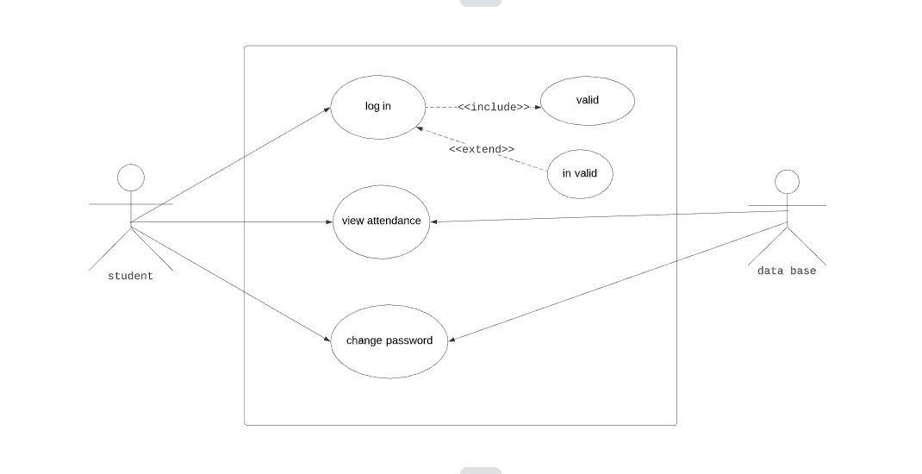

- SCREEN HOME PAGE:

ADMIN HOME PAGE:
FACULTY HOME PAGE:

STUDENT HOME PAGE:

ADMIN LOGIN PAGE:

FACULTY LOGIN PAGE:
STUDENT LOGIN PAGE:

FACULTY REGISTRATION PAGE:

STUDENT REGISTRATION PAGE

STUDENT ATTENDANCE REGISTERTION PAGE:

CHANGE PASSWORD FOR FACULTY:
CHANGE PASSWORD FOR STUDENT:

VIEW STUDENT DETAILS PAGE:

VIEW FACULTY DETAILS PAGE:

VIEW STUDENT ATTENDANCE PAGE:

UPDATE STUDENT DETAILS PAGE:

UPDATE STUDENT ATTENDANCE PAGE:

DELETE FACULTY PAGE:

DELETE STUDENT PAGE:

10. DATABASE DESIGN
DATABASE TABLES:
- register
FIELD NAME | DATA TYPE | Key
Name | Varchar | Primary key
Student id | Varchar
Gender | Varchar
Phone number | Varchar
e-mail | Varchar
address | Varchar
User name | Varchar
password | Varchar
Confirm password | Varchar
Rollno | Varchar
.fareg
FIELD NAME | DATA TYPE | Key
Name | Varchar | Primary key
faculty id | Varchar
department | Varchar
Gender | Varchar
date of birth | Varchar
Phone number | Varchar
e-mail | Varchar
address | Varchar
user name | Varchar
password | Varchar
confirm password | Varchar

- log
Field Name | Data Type | Key
username | Varchar | Primary key
password | Varchar

- atten
Fiel dName | Data Type | Key
Name | Varchar | Primary key
Rollno | Varchar
password | Varchar
July | Varchar
August | Varchar
september | Varchar
October | Varchar
november | Varchar
december | Varchar
January | Varchar
February | Varchar
March | Varchar
April | Varchar
May | Varchar
June | Varchar

11. TEST REPORT AND TEST PLAN
Software testing is an investigation conducted to provide stakeholders with information about the quality of the product or service under test. Software testing also provides an objective, independent view of the software to allow the business to appreciate and understand the risks of software implementation. Test techniques include, but are not limited to, the process of executing a program or application with the intent of finding software bugs (errors or other defects).
Software testing can also be stated as the process of validating and verifying that a software program / application / product:
Meets the business and technical requirements that guided its design development;
1. Works as expected ; and
2. Can be implemented with the same characteristics.

Software testing, depending on testing method employed, can be implemented at any time in development process. However, most of the test effort occurs after the requirements have been defined and coding process has been completed. As such, the methodology of the justice governed by the software development methodology adopted.

Different software development models will focus the test effort at different points in development process. Newer development process such as Agile, often employee test driven development and place an increased portion of the testing in hands of developer before it reaches a formal team of tester. In a more traditional model, most of the test execution occurs after the requirements have been defined and the coding process has been completed.

TEST REPORT:

1. PROJECT NAME:ONLINE ATTENDANCE MANAGEMENT SYSTEM FOR ORGANIZATION
2. FORM NAME: ADMIN LOGIN
3. UNIT NAME: userid, password
4. TEST RESULT: After entering two fields the user(admin) successfully logs into the
system.

TEST PLAN 1:

Unit id: Login
Test case id: userid
Test Type: Unit Testing
Form Name: admin Login
Base Table: log
Purpose: To give access to user after he enters valid user id
Description: Userid varchar (20), Primary Key.
TEST DATE:

S.NO | Input | Excepted output | Results
1. | userid:  password: | Login-Success  Screen  (or)  Error Message | Login-in  Success  Screen  Login Page

TESTPLAN 2
Unit id: student login
Test case id:student id
Test Type: Unit Testing
Form Name: log_in
Base Table: register
Purpose: To give access to user after he enters valid user id.
Description: rollno varchar (20), Primary Key.

S.NO | Input | Excepted output | Results
1 | rollno:  password: | Login-Success  Screen  (or)  Error Message | Login-in  Success  Screen  Login Page

12. CONCLUSION

Online Attendance System has many advantages over the traditional attendance system . It is of less cost , less time consuming , efficient , accurate and low risk of human and mechanical errors . Future development focused to design a system which can be easy to use and will provide security and privacy to the details on acceptable level by proper authentication and processing section

13. BIBLIOGRAPHY

JAVA USER SITE: www.java.com
JAVA SPECIFICATIONS: 2 Ed.Java.Sun.com

JAVA UPGRADES GUIDE: migration from Microsoft VM for java to sun
JRE: java.sun.com
JAVA VIRTUAL MACHINE: Wikipedia

http://en.wikipedia.org/wiki/javaserver_pages
http://en.wikipedia.org/wiki/java_database_connectivity
http://en.wikipedia.org/wiki/javaserver
http://www.ecil.co.in
http://www.ecil.gov.in

